Registering for myhealthkey

My provider has sent me a registration invite for myhealthkey, now what?!

- Open your preferred web browser on a computer, tablet or mobile device (for the purposes of registration, you may wish to try a computer if you have one available to you, to ensure that the full registration form is easy to view and complete). Examples of web browsers include: Google Chrome, Firefox or Safari. We recommend Google Chrome when possible although you should not face any issues using a different type of web browser as long as it is an up-to-date version.
- Navigate to your email program (on some devices you may have an ‘app’ you use to open your email program rather than going to your email through your internet browser – do what works best and easiest for you for this part!)
- Find the Registration Email. It will look similar to this:

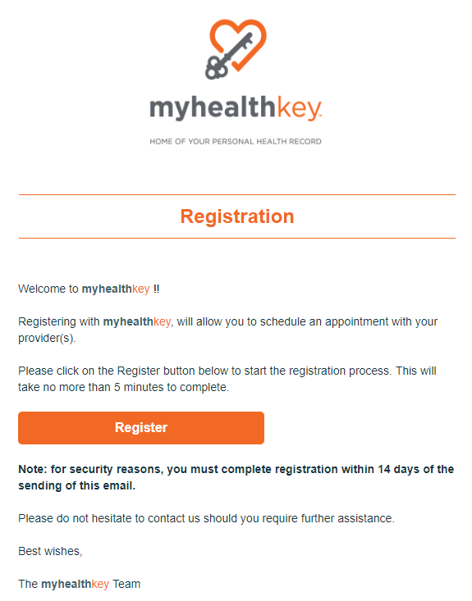

Hints:

- Make sure to check your spam or junk folders if you do not see it in your inbox! The invite should arrive fairly quickly after your clinic has sent it.
- If you still do not receive it within 24 hours, please reach out to your clinic to verify the spelling of your email address with them and to request a new invite.
- If you find the registration email in your junk/spam folders you can typically mark the sender as ‘safe’ so that all further emails will be added to your inbox.
- Your invite is good for 14 days; if you do not complete the registration in 14 days you will need to request a new invite from your clinic.

When you are ready to complete your registration, please click on the orange Register button contained in the email.

Registration Steps:

After clicking on the orange Register button, you will be asked if you are a New User or an Existing User. If you already have a login for www.myhealthkey.ca you should pick Existing User. This might be the case if you have another provider who uses myhealthkey and you’ve already signed up for an account through them. If you do NOT have a login for myhealthkey please select New User.

New User Registration:

The registration for a New User is a 4 step process:
- Confirm your identity/ demographics
  - The demographics you enter on this form MUST match with what the clinic has on file for you. If you receive an ‘information mismatch’ error when attempting to complete this form, that means you are entering something different than what the clinic has on file for you. If this happens, please reach out to your clinic directly to confirm the exact spelling and formatting of your details so that you know what to enter on this form. If any of your details require updating at the clinic, they will need to send you a new invite after updating your information.
  - On this page, you will also be asked to enter a password which you will use for your login. The password MUST match the password criteria before the form will allow you to input the 2nd password confirmation field. If you are not able to type into the second password field on the registration form, this means that your password does not yet meet the password criteria. The password criteria is: Password length must be a minimum of 8 characters and must include 1 capital, 1 numeric, and 1 special character such as: $%!@#^&.
  - You will be asked to confirm your email address. This becomes your username to login to the website.
- Set up your Security Questions and Answers
  - You will be asked to set up 3 security questions and answers. This helps to verify your identity when logging into the website on a new device and can also help you with resetting your password if you forget it down the road.
- Read through and agree to the Terms of Use
- Read through and agree to the Privacy Policy

That’s it! You will see a confirmation message that your registration has been completed!

You can now login to the website at anytime by opening your preferred web browser on any device and going to: www.myhealthkey.ca

Hint: you can save this as a ‘favorite’ or ‘bookmark’ the website for easy access! You can even drag and drop a ‘bookmark’ onto your desktop if you are using a computer to create a shortcut for the website right on your desktop.

Existing User Registration:

If you already have a login at www.myhealthkey.ca and you are subscribing to an additional clinic, you should select Existing User after clicking on the orange Register button. You will then be taken to the homepage of myhealthkey where you can login to your account. Once logged in, you will be asked to confirm if you want to link your account to this new clinic. By selecting Accept you will now be subscribed to the new clinic.

